**EXPERIMENT -1**

(BY: AMAN TYAGI)

AIM: Installation and execution of vagrant

1. Download vagrant from <https://www.vagrantup.com/downloads.html>.

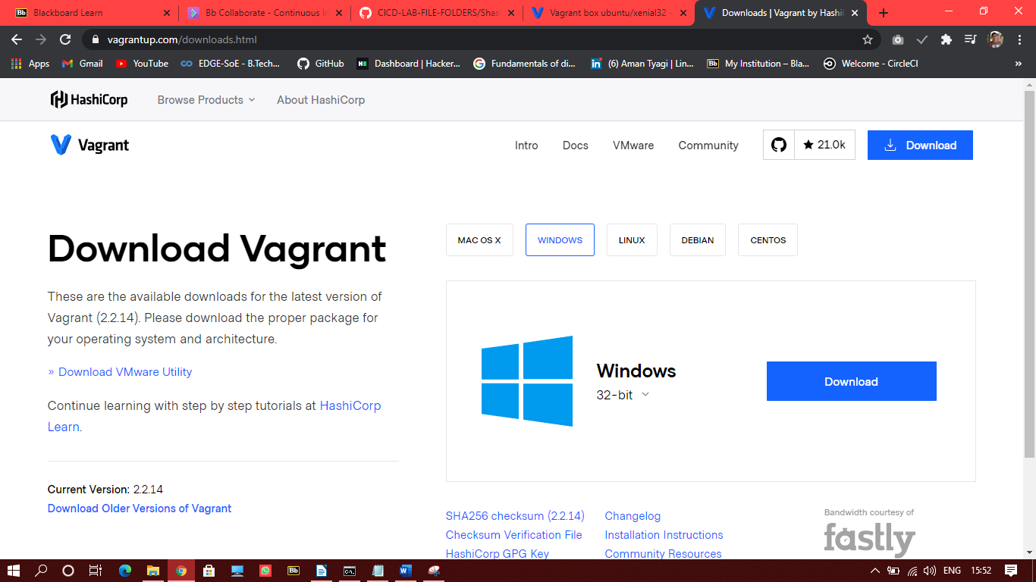

1. Install vagrant and restart your computer and check that vagrant is installed

